Web application Report
Database
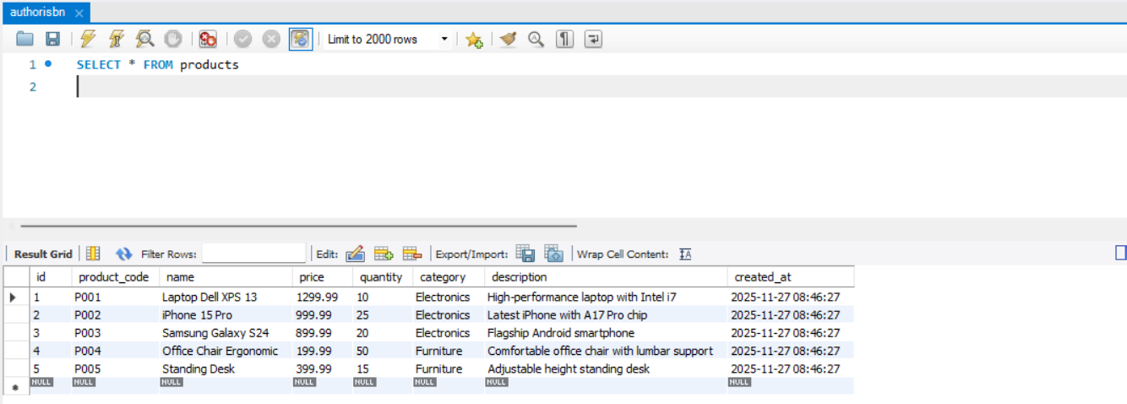
Setup
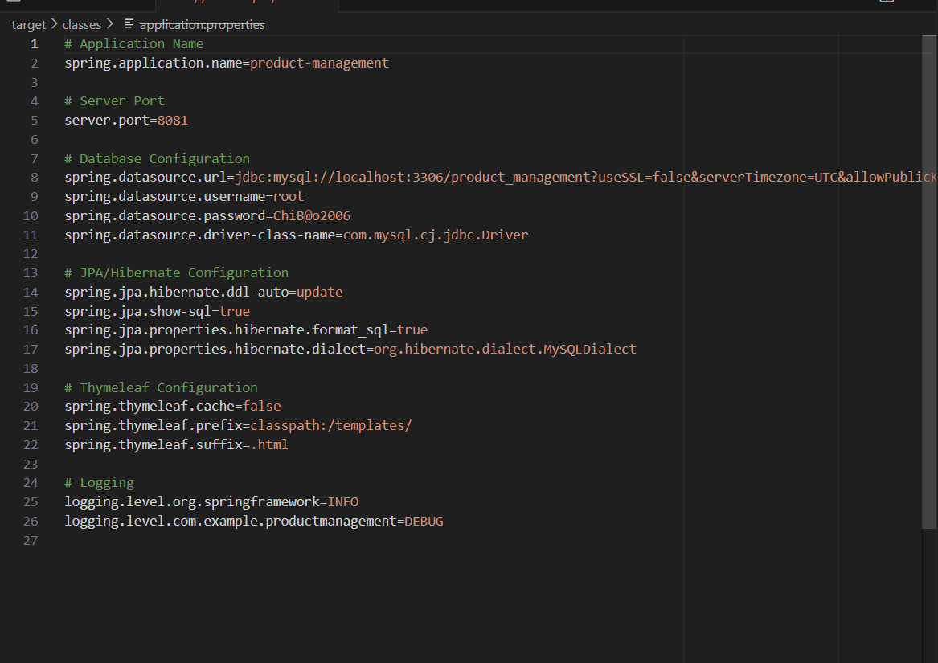
Show product
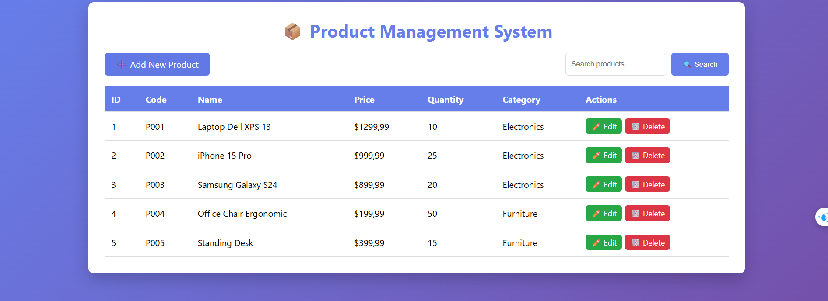
Using html code from the guild in hackio to make this lab
Product
This class represents a Product table in the database using JPA annotations.
It contains fields like productCode, name, price, quantity, category, and description.
The id is the primary key and is auto-generated using IDENTITY.
A created At timestamp is automatically set before the entity is first saved (@PrePersist).
Standard getters, setters, and a toString() method allow easy access and debugging of product data.
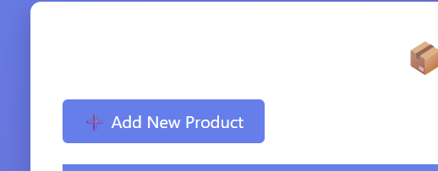
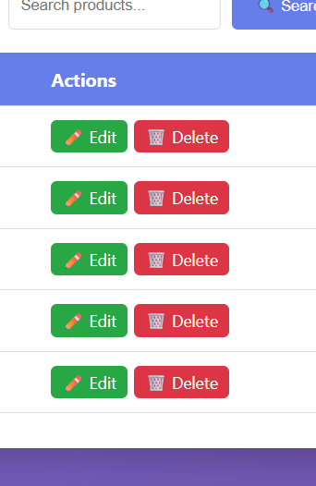
Productcontroller
This controller handles all web requests under /products for listing, creating, editing, deleting, and searching products.
It uses ProductService to interact with the database and retrieve or modify product data.
listProducts() loads all products and displays them on the product-list page.
showNewForm(), showEditForm(), and saveProduct() manage the product creation and update workflow.
deleteProduct() removes a product, while searchProducts() filters products by keyword and returns the results.
ProductRepostity
This interface extends JpaRepository, giving you all basic CRUD operations for the Product entity.
Spring Data JPA automatically generates the SQL queries based on the method names.
findByCategory() retrieves all products that match a specific category.
findByNameContaining() performs a keyword search on product names.
Other methods allow filtering by price range, sorting by price, and checking if a product code already exists.
ProductService
This interface defines the business-logic operations for managing products in the application.
getAllProducts() returns a list of all products stored in the system.
getProductById() retrieves a single product wrapped in Optional to safely handle missing data.
SaveProduct() handles both creating new products and updating existing ones.
Additional methods allow deleting products, searching by keyword, and filtering by category.
ProductServiceImpl
This class implements the ProductService interface and contains the actual business logic for managing products.
It uses ProductRepository to interact with the database for all CRUD operations.
getAllProducts() and getProductById() retrieve product data.
saveProduct() creates or updates a product, while deleteProduct() removes one by ID.
Additional methods allow searching by keyword and filtering products by category

